Mini Transaction Risk Monitoring System

overview

This project is small fraud detection system that identifies fraud transaction on specific rules.
its highlights these transactions and displays their counts on a dashboard

Main Features

1-Upload transaction form
2-List all transaction,highlighting High Risk and Suspicious transactions
3-Dashboard analytics showing total transactions and red-flagged counts

Backend

1. Transaction Form (post api)
- Submit transaction details via a form.
- Post transaction using the POST/transactions API.
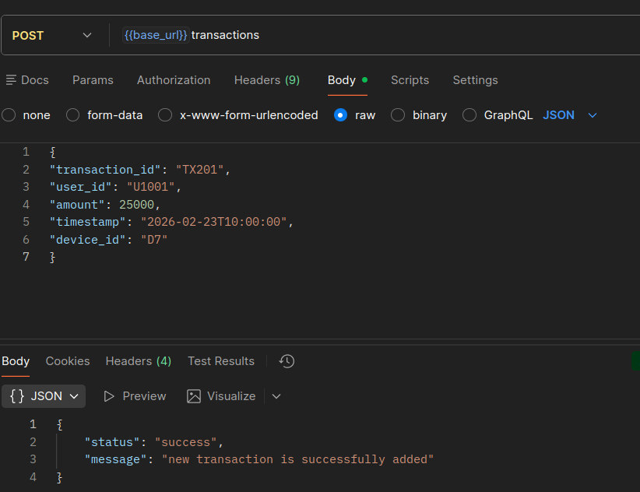

2. Validation Checks
- Ensure all fields are filled.
- Verify the data types for each field.
- Confirm that the transaction amount is greater than 0.
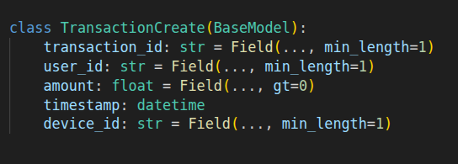

3. Duplicate Transaction Check
- If the transaction is valid, check whether the transaction ID already exists in the system.
- If a duplicate transaction is found, return:
"Transaction ID is already exists"
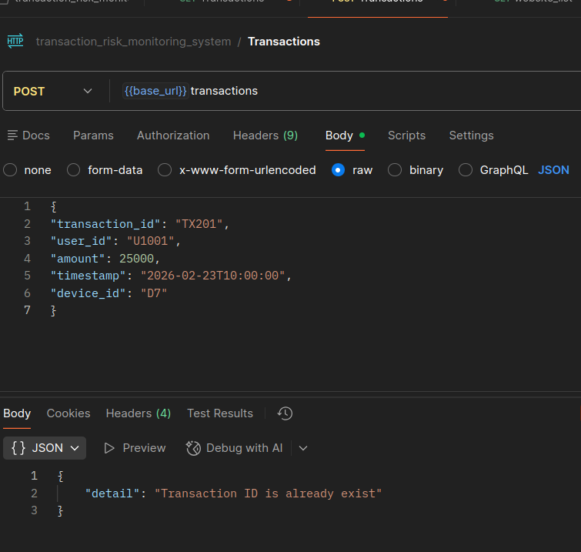

4. Fraud Rule Evaluation
If the transaction is not a duplicate, evaluate it based on the following rules:

Rule 1 High Risk
- If the transaction amount is greater than 2000, mark it as High Risk.

Rule 2: Suspicious Activity
- If a user performs more than three transactions, mark the transaction as Suspicious.

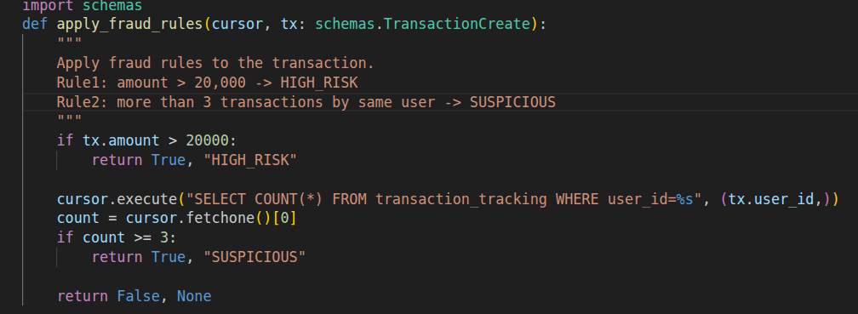

7. Store Transaction
- Store all transactions in the database.
- Save the corresponding flags for High Risk and Suspicious transactions.

7. Get All Transactions
- Retrieve all transactions using the appropriate API endpoint.
- Retrieve all transactions using the GET /transactions API.

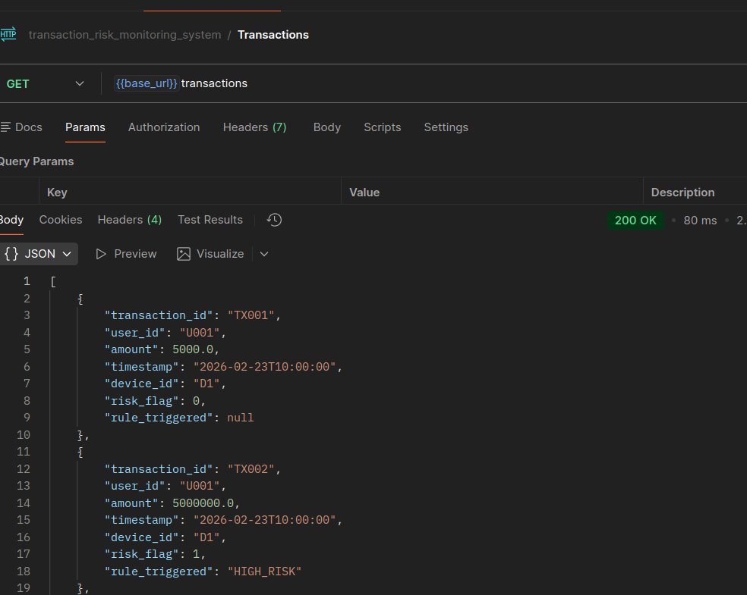

8. Get Dashboard Statistics
- Retrieve dashboard analytics, including total transactions, high-risk transaction count, and suspicious high_risk count
- Retrieve transaction statistics using the GET /dashboard API.

